

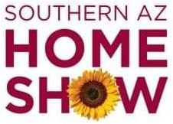

MEDIA CONTACT:

Elise Brown

[elise@elisebrownpr.com](mailto:elise@elisebrownpr.com)

215.990.6955

**Southern AZ Home Show**

**Set to Inspire and Excite Homeowners**

**October 25-27 at Tucson Convention Center**

***Featuring 250+ exhibitors, celebrity experts/twins from***

***the HGTV hit series “Unsellable Houses,”***

***new Culinary Showcase Stage, and much more***

**TUCSON, ARIZONA (SEPTEMBER 18, 2024):** Homeowners and consumers can explore all the newest home trends and connect with more than 250 trusted home professionals and experts when the [**Southern AZ Fall Home Show**](https://www.southernazfallhomeshow.com/) takes place October 25, 26 and 27 at the Tucson Convention Center.

A vibrant marketplace for home-related products and services, the fall **Southern AZ Home Show** (formerly the SAHBA Home Show)is where visitors can shop, compare, and save while gaining new ideas and practical advice in home improvement, interior design, and outdoor living. With everything from kitchens and baths to flooring, décor, and more, there’s something for projects in every home area.

Show Manager Dave Maughan said, “Home improvement is a top priority for most homeowners, and the **Southern AZ Home Show** gives them a single, convenient source for inspiration and consultation with the area’s top professionals about their ideas and home projects.”

Celebrity guest experts Leslie Davis and Lyndsay Lamb, the popular and personable twin sisters, real estate mavens, home renovators, and stars of the hit HGTV series [*Unsellable Houses*](https://www.hgtv.com/shows/unsellable-houses), will share their successful methods with show visitors on Friday, October 25 at 1 pm and Saturday, October 26 at 1 pm. After building their Pacific Northwest-based Lamb & Co. into a successful, full-service real estate and home design company, and skillfully transforming dozens of tough-to-sell homes, the two have become known nationwide as go-to experts for homeowners, designers, renovators and DIY-ers.

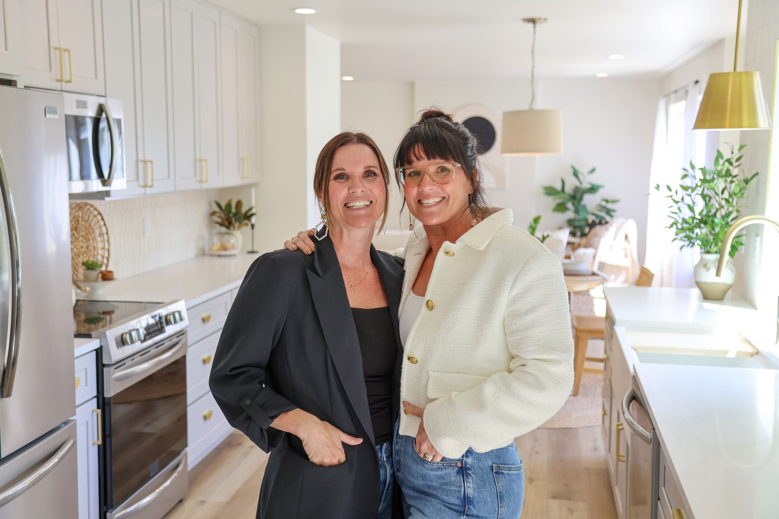

**Twin sisters Leslie Davis (L) and Lyndsay Lamb (R) from HGTV’s hit series *Unsellable Houses***

**will give presentations on Fri. Oct. 25 and Sat. Oct. 26**

An exciting element added to the show is the new Culinary Showcase Stage presented by Workman Company, where audience members can watch local experts perform live cooking demonstrations, get close-up views of their techniques, and taste freshly prepared samples. “Tucson is well-known as a great food city, so we feel visitors will really enjoy this new feature,” Maughan said.

More features of the fall **Southern AZ Home Show** include:

* The Fresh Ideas Stage - At 12 pm each day, audience members can guess the prices of various home-related products and services for the chance to win valuable prizes in the fun *Price Pursuit* game show. Visitors can also enjoy presentations by local experts and entertaining performances by Kids Unlimited, Danzacultura Mexicana, and The Haggs of Tucson (full schedule can be seen at [SouthernAZFallHomeShow.com](http://southernazfallhomeshow.com))
* The Artisans Market - Unique shopping area showcasing small businesses and artisans offering a variety of one-of-a-kind gift items, handcrafted treasures, gourmet foods and more. *Sponsor: Renewal by Andersen*
* Fall Tablescape - Stunning display of seasonal elegance that creates an inviting atmosphere and inspires visitors to create their own beautiful autumn celebrations. *Sponsor: Frenchy’s Wedding & Event Rentals*
* Petopia - Dedicated to four-legged family members, with the best products and services to make their lives better along with adorable, adoptable dogs from Rescue a Golden of AZ
* Halloween Spooktacular **-** Spooky fun throughout the weekend, including trick-or-treating, a scavenger hunt, and a costume parade, plus free admission for all costumed visitors on Sunday, Oct. 27
* Food Trucks - Delicious local fare available in the fire lane outside of the exhibit hall

Show hours:

Friday, October 25 10 am to 6 pm

Saturday, October 26 10 am to 6 pm

Sunday, October 27 10 am to 6 pm

Tickets valid for one admission for one day are available at the box office at the Tucson Convention Center during the show:

* **Adults**: $8 each. A 50 percent discount coupon is available at <https://www.southernazfallhomeshow.com/savings-coupon>
* **Children**: Free admission for children ages 12 and under
* **Seniors**: Free admission for seniors ages 65+ (with ID) on Friday, Oct. 25, and half off admission on Saturday, Oct. 26 and Sunday, Oct. 27
* **Heroes**: Free admission for active and retired military personnel, firefighters, police, first responders and teachers (with ID) on Sunday, Oct. 27, and half off admission on Friday, Oct. 25 and Saturday, Oct. 26
* **$2 admission** during the last two hours of the show each day (4-6 pm)
* Free admission on Sunday, Oct. 27 for visitors in Halloween costumes

Location is the Tucson Convention Center, 260 S. Church Ave., Tucson, AZ 85701

Parking is free in the city parking lots next to the Tucson Convention Center. A free shuttle will also operate between the Ramada by Wyndham parking lot and the Convention Center during show hours.

All show information can be found at [www.SouthernAZFallHomeShow.com](http://www.southernazfallhomeshow.com). Follow the **Southern AZ Home Show** on [Facebook](http://www.facebook.com/SouthernAZHomeShow) and [Instagram](http://www.instagram.com/SouthernAZHomeShow).

# # #

**MEDIA CONTACT:**

For media access, interviews and info, contact:

Elise Brown | [elise@elisebrownpr.com](mailto:elise@elisebrownpr.com) | phone 215.990.6955

**SHOW IMAGES** **FOR MEDIA USE:** <https://bit.ly/3zXAndV>

**PRODUCED BY MARKETPLACE EVENTS**

Marketplace Events creates vibrant expositions connecting enthusiasts with experts, products and services in dynamic face-to-face environments.  The company produces more than 100 business-to-consumer and trade shows in North America, including almost 70 home and garden shows, 18 sport and outdoor shows, 16 holiday shows and 10 regional trade shows. The 100+ combined events, in 54 markets, currently attract 30,000 exhibitors, 2.5 million attendees and another 5 million unique web visitors annually. The company produces some of the most successful and longest-running shows in North America, including market-leading shows in Seattle, Minneapolis, Indianapolis, Vancouver, Calgary and Montreal—some of which have thrived in their markets for more than 75 years. For a full list of upcoming events visit [www.marketplaceevents.com](http://www.marketplaceevents.com/).