



MEDIA CONTACT:

Elise Brown

[elise@elisebrownpr.com](mailto:elise@elisebrownpr.com)

215.990.6955

**Southern AZ Home Show to Bring Home Improvement Inspiration, Top Resources, and Celebrity Experts**

**to Tucson Convention Center March 28-30**

**Kevin O’Connor of PBS’s *This Old House* and best-selling author**

**of *Big Thrift Energy*, Virginia Chamlee, to appear**

**TUCSON, ARIZONA (FEBRUARY 20, 2025):** More than 200 of the area’s top home improvement professionals, the newest trends, and insights from celebrity experts will enlighten and inspire Tucson-area homeowners and consumers when the [**Southern AZ Home Show**](https://www.southernazhomeshow.com/) takes place from Friday, March 28 through Sunday, March 30 at the Tucson Convention Center.

As Southern Arizona’s largest and most comprehensive home show, the three-day **Southern AZ Home Show** features displays, events, demonstrations and informative sessions designed to help facilitate home projects. Show attendees can shop, compare and save while gaining new ideas and practical advice in home improvement, home design, and outdoor living, all in a vibrant marketplace showcasing the latest home-related products and services.

“Spotlighting the area’s top home improvement resources, and sharing information and expertise that can’t be found elsewhere, makes the show a vital and efficient experience,” said Show Manager Lucy Ferguson. “Visitors can save time by exploring an abundance of sources for everything they need for transforming their homes, and get insights directly from recognized experts."

Two such experts will give presentations from the show’s Fresh Ideas Stage on Friday, March 28 and Saturday, March 29:

**Kevin O’Connor**, one of the nation’s most well-known home improvement figures as host of the long-running, Emmy Award-winning PBS television series *This Old House* and *Ask This Old House,* will share some of his extensive experiences, answer audience questions, and meet show attendees Friday, March 28 at 3 p.m. and Saturday, March 29 at 11 a.m. Since 2003, O’Connor has hosted *This Old House,* the leading multimedia home enthusiast brand serving more than 20 million consumers each month with trusted information and expert advice.

**Virginia Chamlee**, writer, artist, and author of the best-selling book *Big Thrift Energy: The Art and Thrill of Finding Vintage Treasures - Plus Tips for Making Old Feel New*, will help visitors learn how to find and transform thrift shop treasures when she presents “How to Thrift Museum-Quality Art, Designer Furniture and More.” She’ll also meet visitors after her talks on Friday, March 28 at 2 p.m. and Saturday, March 29 at 12:30 p.m.

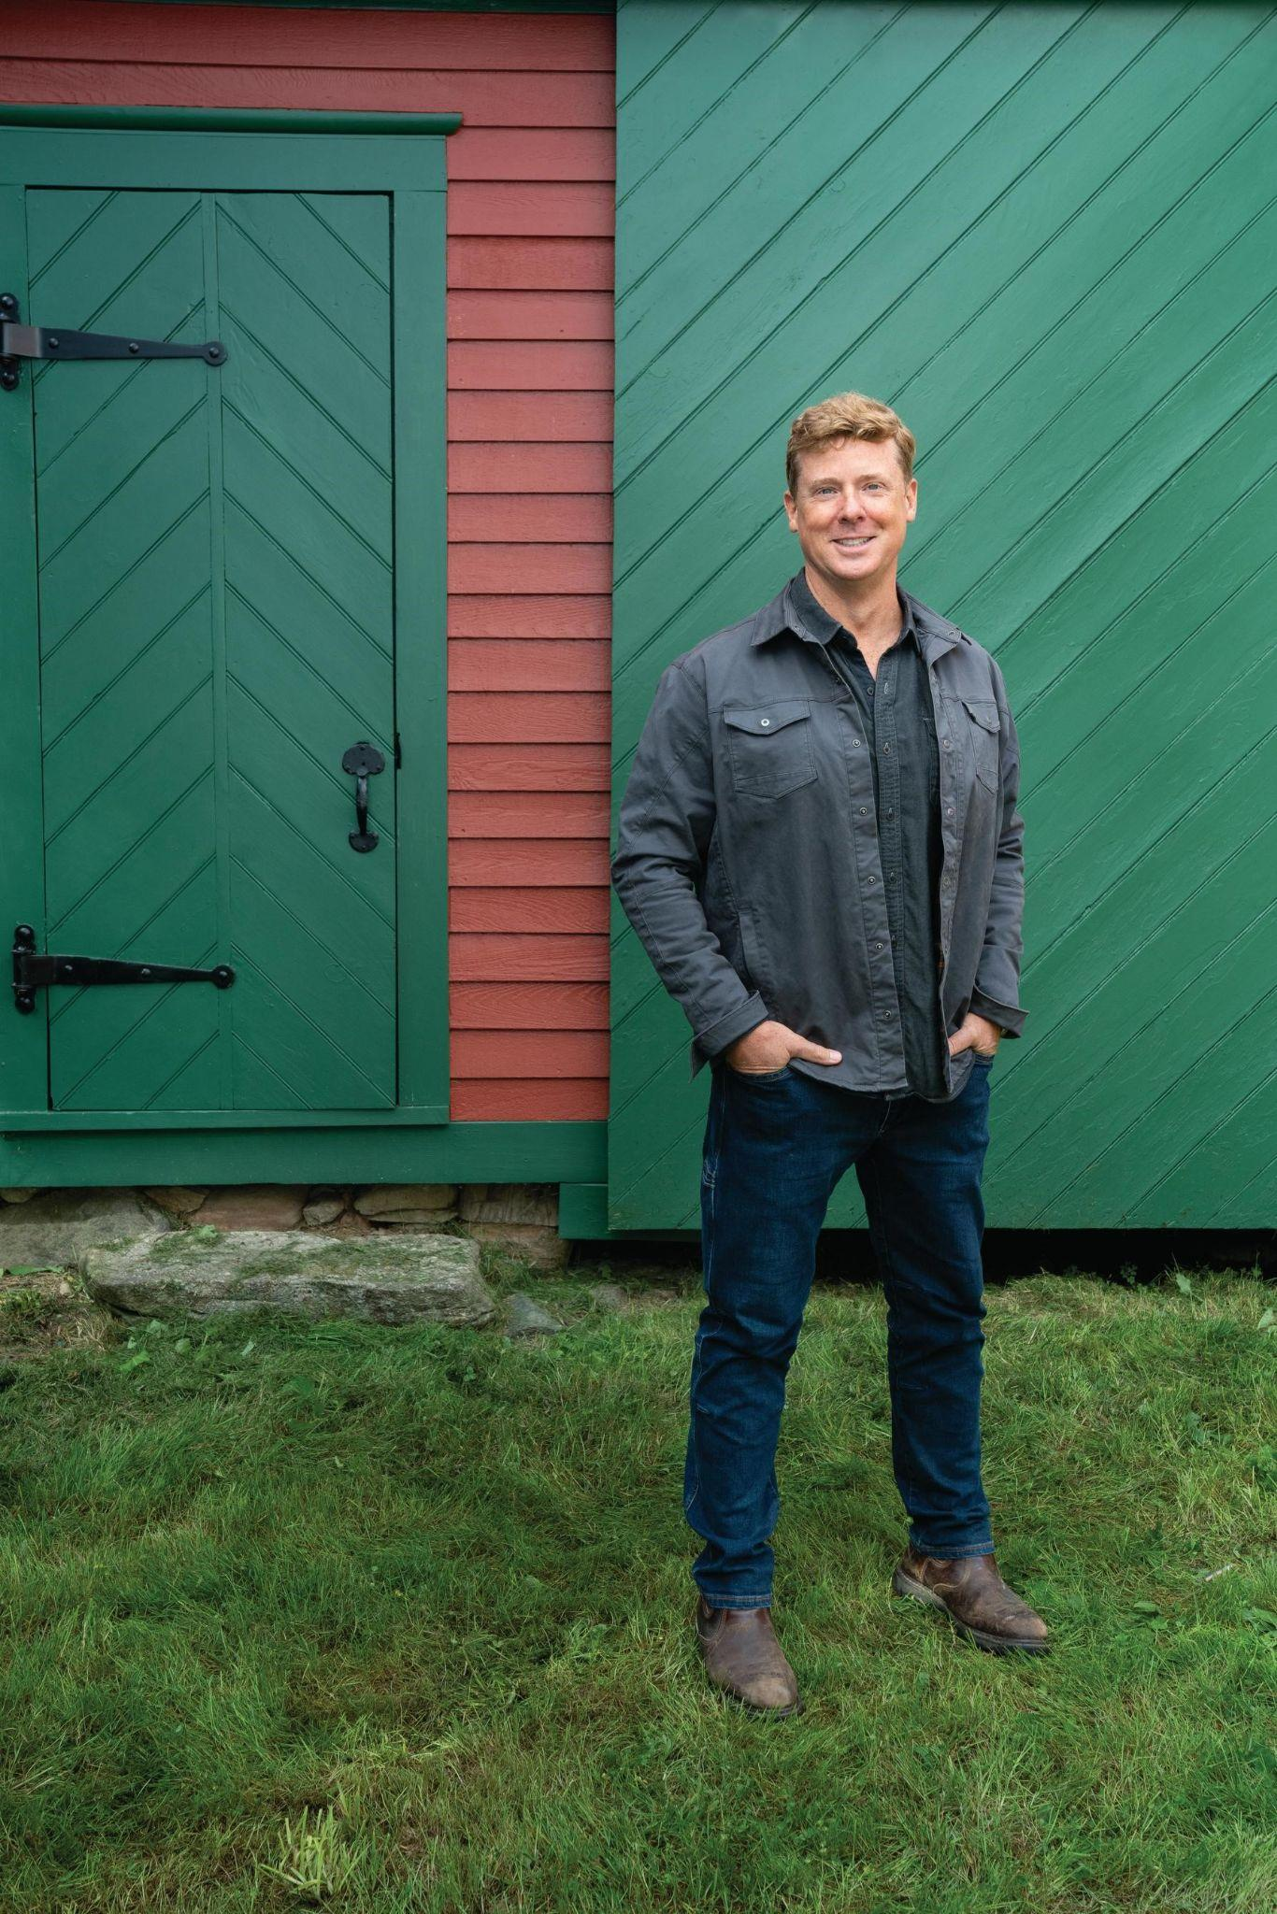 

*Experts Kevin O’Connor (L) and Virginia Chamlee (R) will enlighten attendees*

*at the Southern AZ Home Show March 28 & 29*

The **Southern AZ Home Show** will also feature:

* More than [**200 exhibitors**](https://www.southernazhomeshow.com/virtual-home/shop-the-show) representing the area’s top home products and services offering their insights and [show specials](https://www.southernazhomeshow.com/IEL/promotions) to attendees
* **The Fresh Ideas Stage** - A lineup of knowledgeable local experts sharing their insights and best advice on home topics, plus entertainment from prominent local music and dance groups
* **Culinary Showcase Stage** **presented by Workman Company** - Local chefs and culinary artists performing live cooking demonstrations, providing visitors with close-up views of their techniques and freshly prepared samples, including cake and cookie decorating techniques just in time for Easter
* **The Artisans Market** - Market area showcasing local vendors and small businesses offering a variety of one-of-a-kind gift items, handcrafted treasures, gourmet foods and more
* **The Perfect Picnic** - Wicked Picnic Events presents a deluxe display showing visitors how to re-imagine and elevate their own Spring picnics
* **Petopia** - The best products for your pets, and your home life *with* them, along with adorable and adoptable pets from Rescue A Golden AZ and Southern AZ Cat Rescue
* **Photos with the Easter Bunny** - Meet the Easter Bunny and snap a fun photo! Stop by for a festive meet-and-greet, perfect for kids and families, in Booth A303 on Friday, March 28 and Saturday, March 29 from 11 am -1 pm
* **Food Trucks** - Lunch and more is available all day from food trucks in the fire lane outside the Exhibition Hall

Show dates and hours: Friday, March 28 through Sunday, March 30 - 9 a.m. to 5 p.m.

Tickets valid for one admission on one day of the Spring **Southern AZ Home Show** are available at the box office at the Tucson Convention Center during the show:

* Adults: $8
* Children age 12 and under: free
* Senior Day, Friday, March 28: One free admission for seniors ages 65+ (with ID)
* Sat., March 29 and Sun., March 30: Seniors age 65+ (with ID) get half off admission
* Hero Day, Sunday, March 29: One free admission for active military personnel, veterans, fire, police, first responders and teachers (with ID)
* Fri., March 28 and Sat., March 29: Half off admission for active military personnel, veterans, fire, police, first responders and teachers (with ID)
* Every day: Tickets are only $2 for the last two hours of the show (3 p.m. to 5 p.m.)
* A coupon for a 50 percent discount on one adult admission is available at [www.southernazhomeshow.com/savings-coupon](http://www.southernazhomeshow.com/savings-coupon)

Location for the Spring **Southern AZ Home Show** is the Tucson Convention Center, 260 S. Church Ave., Tucson, AZ 85701

Parking is free in the city parking lots adjacent to the Tucson Convention Center. A free shuttle will also operate between the Ramada by Wyndham parking lot and the Convention Center during show hours.

All show information can be found at [www.SouthernAZHomeShow.com](http://www.southernazhomeshow.com). Follow the **Southern AZ Home Show** on [Facebook](http://www.facebook.com/SouthernAZHomeShow) and [Instagram](http://www.instagram.com/SouthernAZHomeShow).

# # #

**MEDIA CONTACT**

For media access, interviews and info, contact:

Elise Brown | [elise@elisebrownpr.com](mailto:elise@elisebrownpr.com) | phone 215.990.6955

**IMAGES:** [**bit.ly/42mTRVB**](https://bit.ly/42mTRVB)

**ABOUT MARKETPLACE EVENTS**

Marketplace Events creates vibrant expositions connecting enthusiasts with experts, products and services in dynamic face-to-face environments. The company produces more than 100 business-to-consumer and trade shows in North America including almost 70 home and garden shows, 18 sport and outdoor shows, 16 holiday shows and 12 regional trade shows. The 110+ combined events, in 54 markets, currently attract 30,000 exhibitors, 2.2 million attendees and another 5 million unique web visitors annually. The company produces some of the most successful and longest-running shows in North America, including market-leading shows in Seattle, Minneapolis, Indianapolis, Vancouver, Calgary and Montreal—some of which have thrived in their markets for more than 75 years. For a full list of upcoming events visit [www.marketplaceevents.com](http://www.marketplaceevents.com/).