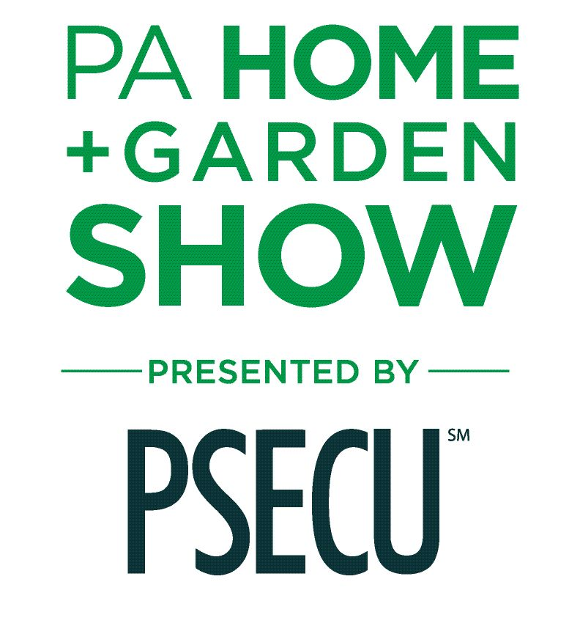

MEDIA CONTACT:
Elise Brown
elise@elisebrownpr.com
215.990.6955

2024 PA Home + Garden Show Set to Inspire Homeowners
February 29 through March 3 in Harrisburg

Get tips from HGTV network celebrity guest experts
Steve Ford (March 1 & 2) and Mina Starsiak Hawk (March 2)

HARRISBURG, PENNSYLVANIA (JANUARY 29, 2024): Consumers can connect with more than 200 home and garden professionals, check out all the newest trends, and get tips from celebrity experts when central Pennsylvania’s largest home and garden show opens on February 29 in Harrisburg. The 2024 PA Home + Garden Show will take place from Thursday, Feb. 29 through Sunday, March 3 at the PA Farm Show Complex & Expo Center.

The PA Home + Garden Show is a vibrant marketplace for home-related products and services, featuring stunning displays to help inspire home projects. Attendees can shop, compare, and save while gaining new ideas and practical advice in home improvement, gardening and landscaping, interior design and more.

Highlighting key community resources while exceeding visitor expectations is the priority for organizers of the region’s premier home and garden show.

Show Manager Jenna Naffin said, “To make the show an even more valuable experience, we’ve expanded the feature gardens and outdoor living displays to more than twice the size from last year’s show, and have increased the number of exhibiting and presenting professionals offering their expertise.”

Celebrity guest experts bringing their home renovation and design experience to show attendees will be Mina Starsiak Hawk and Pennsylvania’s own Steve Ford:

- Mina Starsiak Hawk, star of HGTV network’s popular series Good Bones, will appear on Saturday, March 2 at 1 p.m. The show chronicles the rehabs of dozens of homes in Mina’s hometown of Indianapolis by her Two Chick and a Hammer renovation company. Mina has also starred in the HGTV series A Very Brady Renovation, Rock the Block and Battle On the Beach, and is developing another new series for HGTV.

- Pittsburgh-area native and resident Steve Ford, known from his work on the HGTV series Restored by the Fords, Home Again with the Fords, A Very Brady Renovation, Rock the Block and Property Brothers’ Brother vs. Brother, will appear on Friday, March 1 at 6 p.m. and Saturday, March 2 at 11 a.m. Ford also hosts the online series Stuffed with Steve Ford, which showcases Pennsylvania’s agriculture and food history. The licensed contractor, renovator and author has a diverse portfolio of design and construction work from which he’ll share insights with show visitors.

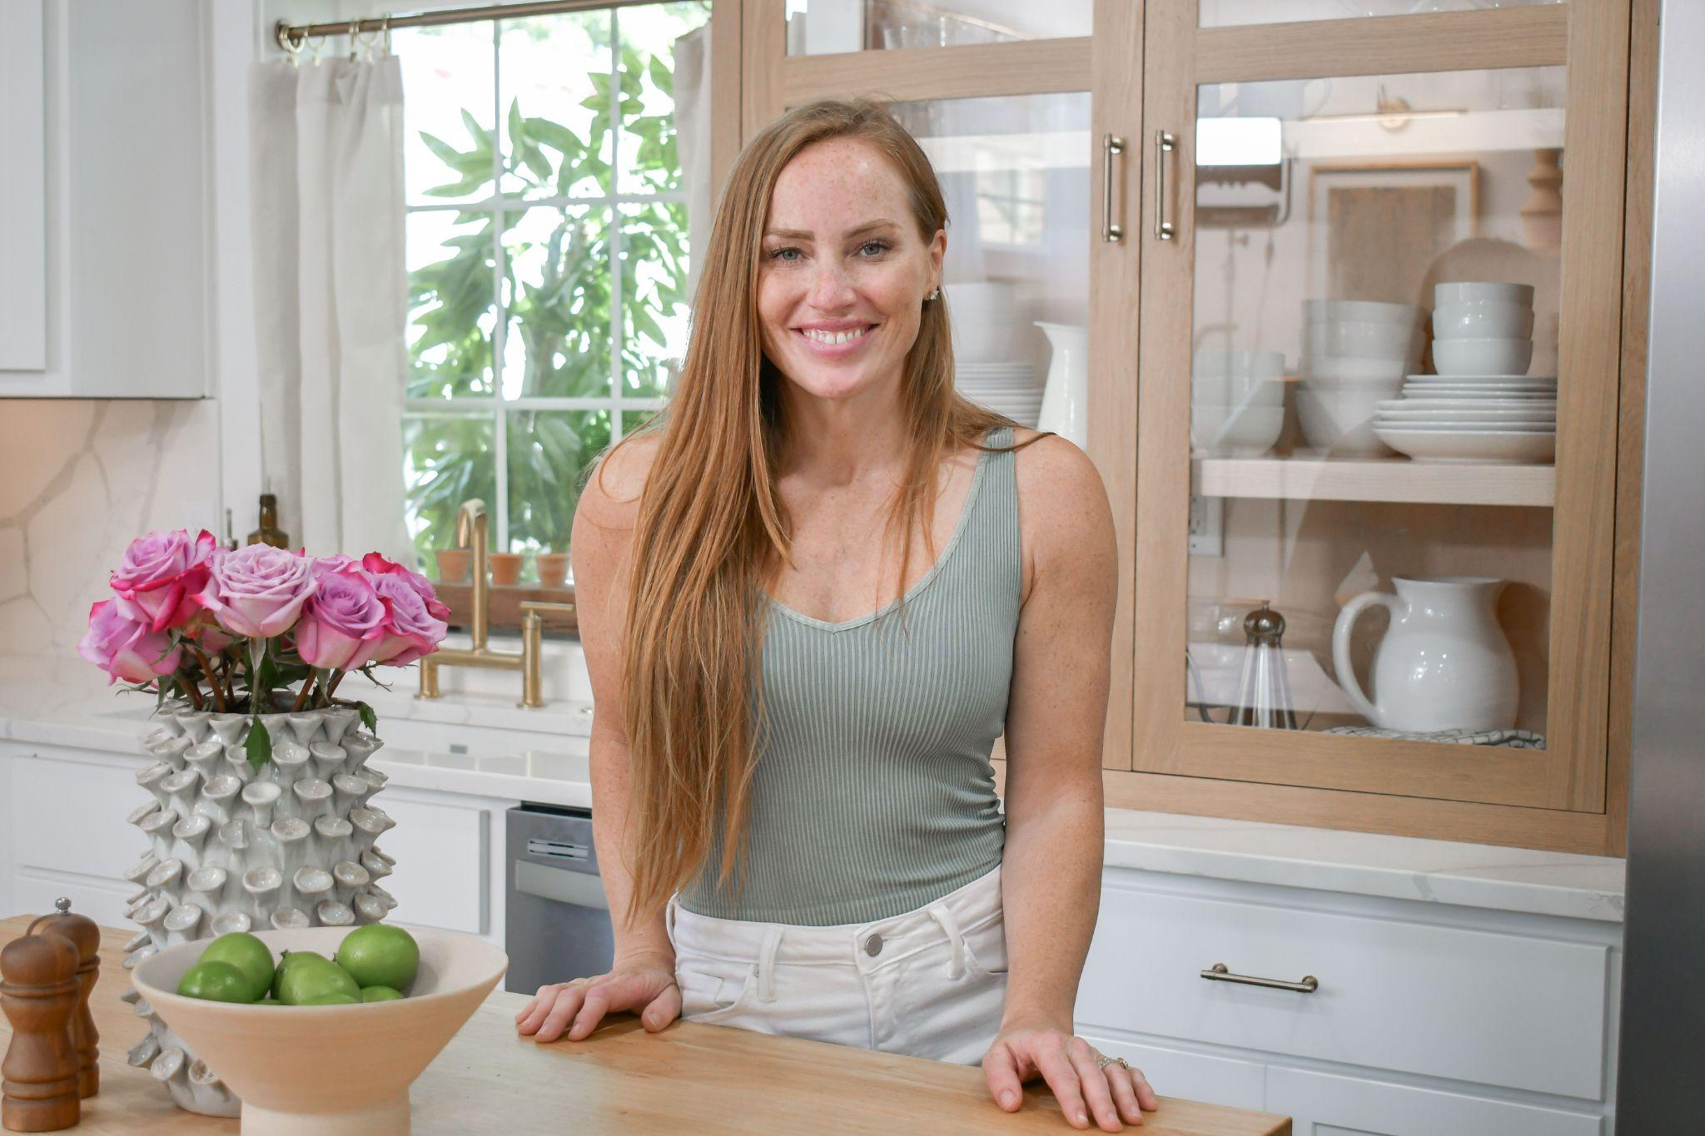
(left) Mina Starsiak Hawk, (right) Steve Ford

This year’s show will also illustrate the hot home trend of “bringing the outdoors in,” through innovative feature displays created by local businesses and designers. Visitors to the 2024 PA Home + Garden Show will experience these features, among others:

- Expansive garden displays and outdoor living exhibits that showcase the latest innovations from A.H. Reiff Landscape Supply and QnC Construction, Burdge’s Water Gardens, and Jesse James Hardscaping

- An abundance of spring plants and flowers from local greenhouses and purveyors, including Bloombox, Ashcombe Farm and Greenhouses’ mobile plant shop, Fern, and Palmyra Greenhouse’s vintage flower-filled truck, Rosie

- Plant Bar where visitors can make their own potted creations to bring home, and a fully-stocked Garden Market loaded with plants, gifts and decor, both from Plantscapes By Design

- Let it Grow! Area where experts from local environmental and horticultural groups provide solutions to visitors’ gardening questions

- He Sheds vs. She Sheds: Innovative outdoor space solutions constructed by the skilled students from Cumberland-Perry Area Career & Technical Center and Dauphin County Technical School

- The latest in cabin living from Zook’s Cabins, featuring a full-size A-frame cabin

- Local libations and more: A relaxing Wine Garden from Juniata Valley Winery, and Hazard's Distillery’s Whiskey Backyard, featuring popular backyard games

- An inviting Backyard Oasis designed by Backyard Bliss, with outdoor elements to delight all family members

- “Bringing the Outside In” design rooms that demonstrate the popular home trend by Fitz Haus Interior Design, with furnishings provided by David’s Interiors in collaboration with Master Designer Duane Bell

- Two specialty markets: Harrisburg’s Homegrown Market, offering unique items from local artisans and retailers, and The Barking Lot pet market, filled with treats, toys and accessories for four- legged family members

- Main Stage presentations by nationally-known and local experts sharing their knowledge and advice in a range of topics - from home ownership to attracting butterflies and creating a low-maintenance, sustainable yard

- Doggy Fashion Show on Sat. March 2 at 12 p.m. - a parade of adorable, adoptable dogs from Canine Rescue of Central PA

Tickets for the PA Home + Garden Show are $11 for adults at the box office, with a $2 discount available when purchased online through February 28. Starting opening day, February 29, the price will increase to $11 online, same as box office pricing. Admission is free for children ages 12 and under. Special discounts available are::

- Senior Day - Thursday, Feb. 29
All show visitors age 60 and over receive a $3 discount on admission at the box office (with valid ID)

- Hero Day - Friday, March 1
All active military personnel, veterans, fire, police and first responders get one free admission at the box office (with valid ID)

- The Book Bank - Show visitors who bring and donate a children’s book for children undergoing treatments at Hershey Medical Center will receive $2 off admission at the box office

Location is the Main Hall at the PA Farm Show Complex & Expo Center, 2300 N. Cameron Street (at Maclay) in Harrisburg, PA 17110. Show visitors should use the Maclay Street entrance.

Show hours, tickets, parking info and more can be found at www.pahomeshow.com. Follow the PA Home + Garden Show on Facebook and Instagram.

# # #

MEDIA CONTACT
For media access, interviews and info, contact:
Elise Brown | elise@elisebrownpr.com | phone 215.990.6955

IMAGES FOR MEDIA USE: https://bit.ly/3NLGc2b
ABOUT MARKETPLACE EVENTS
Marketplace Events creates vibrant expositions connecting enthusiasts with experts, products and services in dynamic face-to-face environments. The company produces more than 70 consumer shows in North America including home, garden and holiday shows. The 70+ combined events, in 34 markets, currently attract 22,000 exhibitors, 2 million attendees and another 3 million unique web visitors annually. The company produces some of the most successful and longest-running shows in North America, including market-leading shows in Minneapolis, Atlanta, Indianapolis, Vancouver, Calgary and Montreal—some of which have thrived in their markets for more than 75 years. For a full list of upcoming events visit www.marketplaceevents.com

