


MEDIA CONTACT:
Elise Brown
elise@elisebrownpr.com
215.990.6955

Experts, exhibits and special guests are set to inspire visitors
at the 2026 Pennsylvania Home + Garden Show
March 5-8 in Harrisburg

Meet celebrity guests Richard Karn and Virginia Chamlee
at central PA’s largest home show

HARRISBURG, PENNSYLVANIA (JANUARY 20, 2026): With more than 200 of the area’s top home and garden professionals showcasing the latest products and trends, the 2026 Pennsylvania Home + Garden Show will provide homeowners and consumers with an abundance of inspiration and solutions from Thursday, March 5 through Sunday, March 8 at the PA Farm Show Complex & Expo Center in Harrisburg.

The region’s largest home show is the most comprehensive and convenient resource for fresh ideas, practical advice, innovative products and fantastic deals in remodeling, home improvement, interior design and outdoor spaces.

As Show Manager Jenna Naffin said, "There’s no need to spend hours searching on the internet when you can make one visit to the Pennsylvania Home + Garden Show to talk to trusted home and garden professionals and find everything you need for your home projects.”

Show visitors will experience a welcome burst of Spring in the show’s expansive gardens and impressive outdoor living displays created by the region’s top landscapers, contractors and nurseries. They can also acquire pro tips from local and national designers and experts, explore small-space living solutions, and shop for fresh Spring flowers, plants, and exquisite, locally-made artisanal items.

But that's just a start - Pennsylvania Home + Garden Show’s many special features and events include:

Celebrity guest appearances

- Richard Karn is known to millions of TV viewers from his role as Al Borland in the hit show Home Improvement and as a former host of Family Feud. He’ll talk about Home Improvement, his own carpentry experience, and more, as well as answer audience questions and meet with attendees following his Main Stage appearances on Friday, March 6 at 6 p.m. and Saturday, March 7 at 11 a.m.

- Virginia Chamlee is the artist, writer, author and thrift shopping expert whose book Big Thrift Energy is the comprehensive guide to finding secondhand treasures. She’ll share her experiences and valuable advice on the Main Stage before meeting with show attendees on Thursday, March 5 at 5 p.m. and Friday, March 6 at 1 p.m.

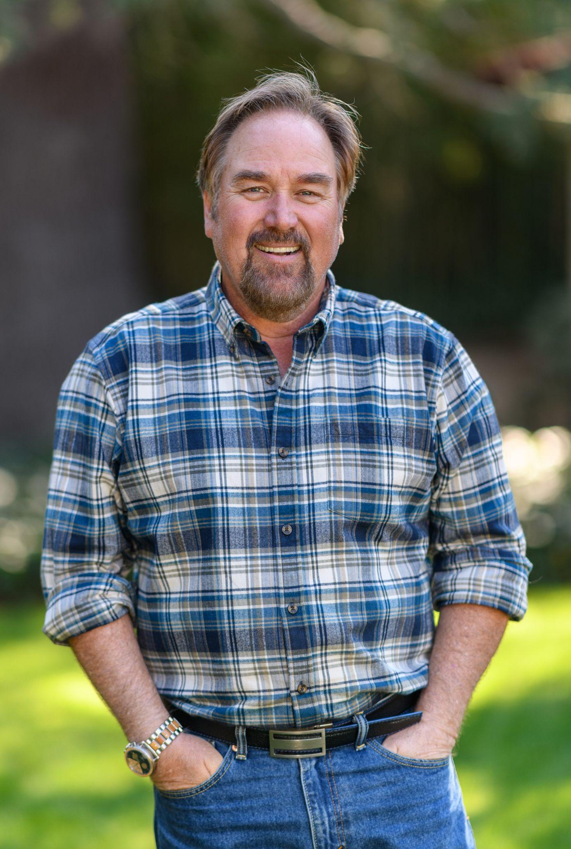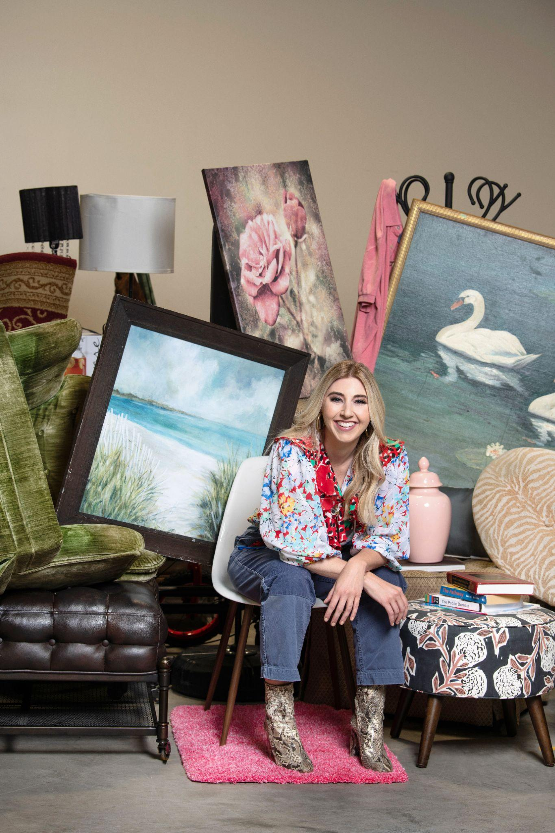
Celebrity guest experts Richard Karn (left) and Virginia Chamlee (right)
will appear at the Pennsylvania Home + Garden Show

Exclusive features

- Expansive garden displays and outdoor living exhibits showcasing the latest trends and offering endless inspiration, created by A.H. Reiff Landscape Supply, Burdges Water Gardens, Jesse James Hardscaping, DJR Landscaping, , and QnC Construction

- A plethora of fresh, colorful blooms and spring plants from local greenhouses and purveyors, including Ashcombe Farm and Greenhouses’ mobile plant shop, Fern, and Palmyra Greenhouse’s vintage flower-filled truck, Rosie

- Plant Bar where visitors can design and make their own custom potted houseplants to bring home, and a fully-stocked Garden Market loaded with plants, gifts and decor, both from Plantscapes By Design

- Street of Small Space Living featuring TSI Sheds and Lancaster Log Cabins that demonstrate how compact living solutions - a high-end park model, a stylish cabin, and a cozy A-frame cabin - can enhance your lifestyle, add value to your property, and bring simplicity and sustainability to your life

- Immerse Yourself In Color with David’s Interiors’ fully-decorated rooms that celebrate rich, saturated hues and layered tones, showing how to embrace color as a statement and turn your home into a masterpiece of bold elegance

- Spring Luxury Picnic & Tablescape by Backyard Bliss is an enchanting, Spring-inspired display that blends luxury picnics, elegant event décor, and artfully designed tablescapes to inspire stylish seasonal gatherings of all sizes

- Local libations and more: Sample and bring home wines from Juniata Valley Winery’s relaxing Wine Garden, and play family-friendly backyard games while sampling and purchasing spirits from Hazard's Distillery’s Whiskey Backyard

- Potting Shed Perfection - Built by Dauphin County Technical School students, this attractive and practical structure helps with garden planning, storage and cultivation, and will be auctioned during the show

- Tiny Home - Students from Dauphin County Technical School have built an 8' × 22' tiny home complete with fully functioning electrical and water systems. Perfectly suited as a hunting cabin or simple in-law quarters, this tiny home is a practical and affordable option.

- Ask A Designer! Attendees with questions about home design can consult (for free) with Abby Fitzgerald, interior designer and owner of Fitz Haus Interior Design

- Grow + Gather + Create by Stoltzfus Storage Sheds showcases three trending outdoor spaces—a cozy she shed for relaxation, a lush greenhouse for cultivating plants, and a versatile studio shed for unleashing creativity

- Specialty markets: Harrisburg’s Homegrown Market offers unique items from local artisans and retailers, and The Barking Lot pet market is filled with treats, toys and accessories for four-legged family members, from which a portion of sales will help support Canine Rescue of Central PA

- Doggy Fashion Show on Sat. March 7 at 12 p.m. will feature a family-friendly, crowd-pleasing parade of adorable, adoptable dogs from Canine Rescue of Central PA, all dressed in their Spring finery

Tickets & discounts

- $11 each for adults at the box office, and free for children ages 12 and under

- $2 discount on adult tickets when purchasing tickets online (through March 4)

- $4 adult admission after 4 p.m. (at box office)

- Senior Day - Thursday, March 5
All show visitors ages 60 and over receive a 50% discount on admission at the box office (with valid ID)

- Hero Day - Friday, March 6
All active military personnel, veterans, firefighters, police, first responders, nurses, doctors and teachers get one free admission at the box office (with valid ID)

- Friends & Family Day - Sunday, March 8
Visitors will enjoy 2-for-1 priced tickets after 1 p.m., and fun family activities including free face painting for kids

The Book Bank benefitting The Four Diamonds Fund & Children’s Miracle Network Show visitors who bring a new book to donate to the Book Bank at Hershey Medical Center in Hershey, PA to help to build a “library of love,” will receive $2 off tickets at the box office. The children undergoing treatments at the center will be able to enjoy the books together with their families during a difficult time for them.

Location

PA Farm Show Complex & Expo Center (Main Hall), 2300 N. Cameron Street, Harrisburg, PA 17110. Enter the parking lot as directed and enter using the Maclay Street entrance.

Show hours

Thursday, March 5: 12 p.m. - 8 p.m.
Friday, March 6: 10 a.m. - 8 p.m.
Saturday, March 7: 10 a.m. - 8 p.m.
Sunday, March 8: 10 a.m. - 6 p.m.

More info & social media

Parking info, list of exhibitors, and all other show info is at www.pahomeshow.com
Follow the PA Home + Garden Show on Facebook and Instagram

# # #

MEDIA CONTACT
Elise Brown | elise@elisebrownpr.com | phone 215.990.6955

IMAGES FOR MEDIA USE: bit.ly/4ijEnrn
ABOUT MARKETPLACE EVENTS
Marketplace Events creates vibrant expositions connecting enthusiasts with experts, products and services in dynamic face-to-face environments. The company produces more than 125 business-to-consumer and trade shows in North America, including 65 home and garden shows, 20+ holiday shopping shows, 17 sport and outdoor shows, and 21 regional trade shows. The 125+ combined events, in 50+ markets, currently attract 30,000 exhibitors, 2.2 million attendees and another 5 million unique web visitors annually. The company produces some of the most successful and longest-running shows in North America, including market-leading shows in Seattle, Minneapolis, Indianapolis, Vancouver, Calgary and Montreal—some of which have thrived in their markets for more than 75 years. For a full list of upcoming events visit
www.marketplaceevents.com.

