
FOR IMMEDIATE RELEASE
Media Contact:
Jennifer Sherlock
jsherlock@jennacommunications.com
609.369.3482

All Hands-on Deck! The Philly Home + Garden Show Returns February 20-22 with Celebrity Experts, Fresh Ideas, and Spring Inspiration

Explore 300+ exhibitors, meet fan-favorites Captain Sandy, Kevin O’Connor, and Enjoy Hands-On Experiences for Every Homeowner at the Greater Philadelphia Expo Center in Oaks, PA.
Philadelphia, PA – January 13, 2026 — The Philly Home + Garden Show returns to the Greater Philadelphia Expo Center in Oaks, PA, from Friday, February 20 through Sunday, February 22, 2026, bringing together nearly 300 exhibitors, celebrity guests, immersive feature gardens, hands-on workshops, and shopping experiences designed to inspire homeowners, gardeners, and DIY enthusiasts alike.
For three days only, attendees can shop, compare, and save while discovering fresh ideas, innovative products, and expert advice in remodeling, home improvement, décor, gardening, and outdoor living, all under one roof. One of the region’s most anticipated annual events, the Philly Home + Garden Show brings together hundreds of exhibitors that you can meet with face-to-face, nationally recognized experts, and hands-on features designed to help attendees plan projects, discover new ideas, and connect directly with trusted professionals.
The 2026 show will feature appearances by Captain Sandy Yawn, known for her leadership on Bravo’s hit series Below Deck Mediterranean, and Kevin O’Connor, Emmy-winning host of This Old House and Ask This Old House. Both will take the stage to share insights on leadership, problem-solving, renovation, and real-world home improvement strategies.
From expert-led presentations to interactive installations and family-friendly attractions, the Philly Home + Garden Show offers something for everyone whether planning a major renovation or simply looking to welcome spring with fresh ideas.

PHILLY HOME + GARDEN SHOW 2026 – FEATURE HIGHLIGHTS

Celebrity Guests Take the Main Stage
Home improvement fans will have the opportunity to hear from two nationally recognized personalities:
Meet Captain Sandy Yawn
- Fan-favorite Captain Sandy Yawn, best known as the fearless leader on Bravo’s hit series Below Deck Mediterranean, will take the Main Stage to share her inspiring journey of leadership, resilience, and navigating high-pressure environments, both at sea and in life.


As one of reality television’s most respected captains, Sandy brings real-world insight into teamwork, decision-making, and overcoming challenges, offering audiences motivation that extends far beyond the yacht. Sandy will be presenting on the Main Stage Friday at 6 p.m., and Saturday at 1 p.m.
Meet Kevin O’Connor
- Emmy Award-winning television host Kevin O’Connor, the face of PBS’s beloved This Old House and Ask This Old House, brings decades of renovation expertise and homeowner know-how to the Philly Home + Garden Show.
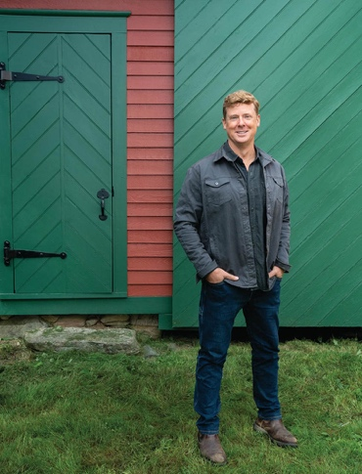
Known for breaking down complex projects into practical, achievable steps, Kevin will share expert advice on home improvement, smart renovations, and long-term planning, empowering homeowners to make confident decisions about their spaces. Kevin will be presenting on the Main Stage on Saturday at 5 p.m., and Sunday at 12 p.m.
(Stage décor sponsored by IKEA.)

Highlights of the Philly Home + Garden Show Include:

🌸 Feature Gardens: Step Into Spring


Get inspired for your outdoor space by exploring a full hall of gardens created by seven of the region’s top landscaping and garden companies. Stroll through more than 9,000 square feet of inspirational gardens showcasing new landscaping techniques, ideas, and must-have products for 2026. Guests can also build their own succulent at the succulent bar and relax in the Wine Garden brought to you by The Renegade Winery.
This full hall of professionally designed gardens is created by some of the region’s top landscaping and garden experts. Each display highlights emerging trends in outdoor living from sustainable plantings and low-maintenance designs to elegant entertaining spaces and backyard retreats.
As attendees stroll through the gardens, they’ll discover creative ideas for patios, walkways, water features, outdoor lighting, and plant pairings that bring beauty and function together. The space is designed not only to inspire, but to help homeowners envision what’s possible in their own yards whether starting from scratch or refreshing an existing space.

🐾 The Barking Lot + Doggy Fashion Show (Fan Favorite Returns)



A beloved show highlight, The Barking Lot is back, bigger, cuter, and more paw-some than ever.
This dedicated pet-friendly shopping area invites attendees to treat their four-legged family members to toys, treats, accessories, and unique finds while supporting a great cause. Vendors participating in The Barking Lot will donate a portion of proceeds to the Pennsylvania SPCA, helping support animals in need throughout the region.
Don’t miss the always-adorable Doggy Fashion Shows, where adoptable dogs from the Pennsylvania SPCA strut their stuff on the runway, showcasing personality, charm, and plenty of tail-wagging style. It’s feel-good fun that highlights the joy of pet adoption and community giving.
Come. Stay. Shop for a good cause. Don’t miss the adoptable dogs of the PA SPCA strutting their stuff in the popular Doggy Fashion Shows on Saturday, February 21 at 12 noon and Sunday, February 22 at 11am!
Children’s Entrepreneur Market

*New this year* The Children’s Entrepreneur Market is an award-winning program that teaches young people about the power of entrepreneurship, innovation, and leadership through experiential learning. Come shop the Children’s Entrepreneur Market Saturday and Sunday from 10am-4pm!

The Spirited Backyard: Presented by Hazard’s Distillery and Rental-World


Unwind after shopping the show with local whiskey tastings from Hazard’s Distillery and enjoy backyard games including cornhole, carnival games, mini golf, and more.

Succulent Bar + Shop

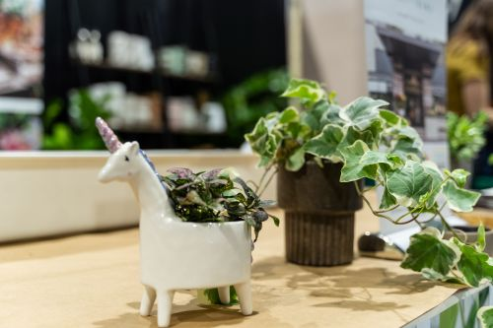
Located in the Garden Hall, Cozy Quarters Décor & More offers unique décor and gift items alongside a DIY Succulent Bar. Choose an exotic succulent, select your pot, and customize it with rocks, stones, and moss to create a personalized take-home plant.

Ask a Garden Expert


Have a gardening question or need help getting started? Visit the Ask a Garden Expert booth in the Garden Hall, provided by the Penn State Extension Master Gardeners.

Philly’s Favorites Market


Shop a curated, open-market-style shopping area featuring local artisans and retailers offering antiques, handmade items, specialty foods, home décor, and original art.

Make It, Take It Workshops: Presented by Little. Tall. Rulers

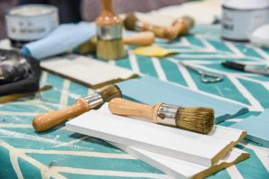
Get creative and take home something new for your space. Work alongside local designers, artists, and crafters to explore what’s trending in DIY. Space is limited; schedules will be announced closer to the show.
Do You Dig It?


Learn about edible landscaping, local honey and bees, and horticultural best practices from regional experts. Whether you’re a beginner or a seasoned gardener, you’ll pick up tips rooted in the motto: garden more, work less.

Discover the Future of Small-Space Living

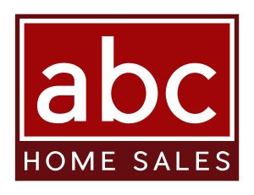
Tour two stunning modular homes built by ABC Home Sales, beautifully furnished by Ethan Allen, showcasing how efficiency, flexibility, and style can coexist in modern living spaces.

Wine Tasting: Presented by The Renegade Winery


Sample wines in the Garden Hall or near the stage and take home your favorites. Furniture provided by Country Tyme Sheds.

Wood-Fired Pizza Pop-Up – Sunday Only


*New this year* On Sunday, February 22 from 11 AM–3 PM, enjoy handcrafted wood-fired pizza from Fiamme del Forno right outside the main entrance.

SPECIAL TICKETING PROMOTIONS
Senior Day – Friday, February 20, 2026
Guests ages 60+ receive 50% off admission at the box office, courtesy of Luxury Bath, with valid ID.
Hero Day presented by Lemus Home Remodeling – Sunday, February 22, 2026
Active and retired military, first responders, nurses, doctors, and teachers receive free admission with identification.
Red Cross Blood Drive

Donate blood during the show and receive a complimentary ticket to the Philly Home + Garden Show.

SHOW DATES & HOURS
Friday, February 20: 11:00 AM – 8:00 PM
Saturday, February 21: 10:00 AM – 8:00 PM
Sunday, February 22: 10:00 AM – 6:00 PM
Location:
Greater Philadelphia Expo Center
100 Station Avenue, Oaks, PA 19456
Tickets:
Adults (Box Office): $12
Adults (Online): $10
Children 12 & Under: FREE
Parking is FREE.
For tickets, schedules, and full show details, visit www.PhillyHomeAndGarden.com.
Instagram: @phillyhomeshows
Facebook: @PhiladelphiaHomeShows
If interested in attending the Philly Home + Garden Show or speaking with one of the show representatives, please contact Jennifer Sherlock at jsherlock@jennacommunications.com.
###
ABOUT MARKETPLACE EVENTS
Marketplace Events creates vibrant expositions connecting enthusiasts with experts, products, and services in dynamic face-to-face environments. The company produces more than 125 business-to-consumer and trade shows in North America including 65 home and garden shows, 20+ holiday shopping shows, 17 sport and outdoor shows, and 21 regional trade shows. The 125+ combined events, in 50+ markets, currently attract 30,000 exhibitors, 2.2 million attendees and another 5 million unique web visitors annually. The company produces some of the most successful and longest-running shows in North America, including market-leading shows in Seattle, Minneapolis, Indianapolis, Vancouver, Calgary, and Montreal—some of which have thrived in their markets for more than 75 years. For a full list of upcoming events visit www.marketplaceevents.com.

