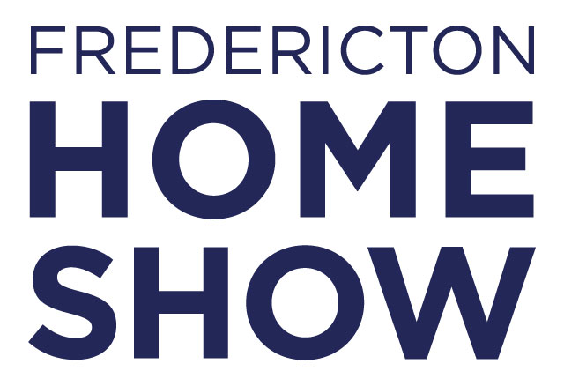
EXAMPLE NEWSLETTER BLURB:
Join us at the 2026 Fredericton Home Show, happening April 10-12 at the Capital Exhibit Centre. The ultimate destination for all things home, you’ll meet hundreds of trusted home experts here to help with your renovation and remodelling projects. —all under one roof.
Make sure to mark your calendars and join us for the Fredericton Home Show! Don’t delay and get your tickets at a discounted price with our unique code:
🎟 Get $3.00 off* any regular Adult ticket
Head to: https://frederictonhomeshow.mpetickets.com/?disc=insertyourcodehere or
Visit and use code insert your code here www.FrederictonHomeShow.ca

*Discount only applies to Adult Tickets ($7) purchased online.
EXAMPLE SOCIAL MEDIA POST:️
Join us at the 2026 Fredericton Home Show, happening April 10-12 at the Capital Exhibit Centre!
This is your chance to meet hundreds of home experts, get inspired, and explore—all under one roof.
Don’t forget to visit us at the show!
🎟 Save $3 on Adult tickets with promo code insert your code here at www.FrederictonHomeShow.ca or https://frederictonhomeshow.mpetickets.com/?disc=insertyourcodehere
*Discount only applies to Adult Tickets ($7) purchased online.

