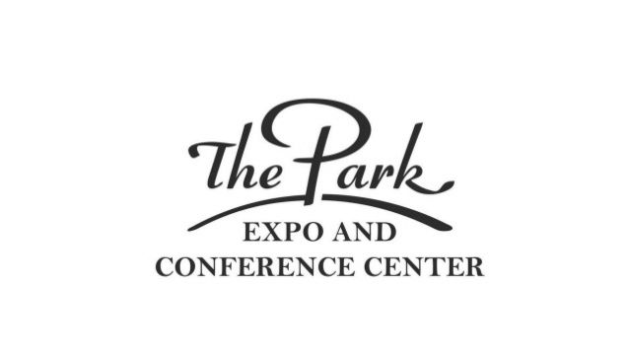The Park Expo and Conference Center

REQUEST FOR FOOD AND BEVERAGE SAMPLING

All food sampling must be approved by The Park Expo
Exhibitors and sponsoring organizations may distribute food samples from their booth.
This form does not give any permissions to sell on-site consumable food items that are not
in factory packaging. Ex. Vacuum packages, bottles, jars & cans etc.

Food / Beverage Sample Guidelines
1. Items are limited to products manufactured or produced by the exhibiting firm
2. All items distributed are limited to sample sizes
a. Beverages limited to 2 ounce max.
b. Food items limited to “bite-size” (1 ounce or less)
3. Use of cooking equipment must have prior approval.
4. Alcoholic beverages: Wine or Beer is the only item allowed by The Park for sampling. Exhibitor must have all necessary off-site permits and comply with all ABC regulations.
5. Food and Beverage storage must be provided by exhibitor.
- The applicant named below acknowledges they have sole responsibility for use, service and disposal of such items in compliance with all applicable laws. Accordingly, the applicant agrees to indemnify and forever hold harmless The Park Expo and Conference Center, Park Property Management, LLC and its agents from all liabilities, damage, losses, costs or expense resulting directly or indirectly from their distribution of food and beverage sample items.

Name of Event ________________________________________

Event Date ______________________________ Booth # ______________________

Company Name ___________________________________________________________

Contact Name________________________ ____ Phone Number_____________________

Address ___________________________________________________________________

City, State and Zip ___________________________________________________________

On-site Contact Name and Cell Phone: ___________________________________________

Product(s) you wish to sample _________________________________________________

__________________________________________________________________________

_________________________________________________________________________

_________________________________________________________________________

Email to : hmills@theparkexponc.com
or Mail completed form to:
Henry Mills 800 Briar Creek Road, AA 506 Charlotte, NC 28205

For questions call, Henry Mills, Business Manager at 980-365-7568

