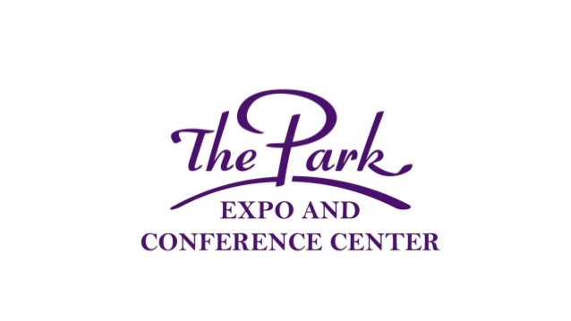 Revised: January 3, 2022
Park Property Management Food Service Policies and Regulations
Food and Beverage Contacts: Manager: Byron Sackett 704-293-3611
Henry Mills Business Manager 980-365-7568 for third party or exhibitor sampling and food sales approval.
Park Property Management (hereafter known as PPM) retains the exclusive right to provide, control and retain all food and beverage rights and services throughout the facility. Catering, concessions, the sale of snacks, pastries, treats and/or candies are included under this provision.
Alcohol Policy
At this time Beer and Wine are the only ABC products available for sale in the facility. Wine and beer tasting is allowed on a per event basis with facility approval. All tasting areas must meet all North Carolina Alcohol Beverage Control regulations and permitting. Proper proof of Insurance must be provided to PPM.
PPM has final say in all ABC sales and determinations during events.
Bar Service can be provided. Contact Food & Beverage Management for pricing.
NO outside Alcohol allowed on The Park Expo property without written permission.
Catering
Please contact the Food & Beverage Manager to discuss your Catering needs. Menus and tasting can be arranged. All food and beverage for events, exhibitor booths, exhibitor lounges, event worker meals, hospitality areas, VIP areas, Green Rooms, etc. must be arranged through the Food & Beverage Manager. Outside Catering or other commercial food is not allowed without written permission. If written permission is granted, a catering fee of 25% will be charged based on final catering bill.

Concession and Food Service Operation Hours
PPM will open concessions/cafes during events and shows. The hours of operations will be determined between Food & Beverage Manager and the Event Organizer prior to event. The main focus of our Food Service is to provide your event staff and show attendees with excellent food and convenient hours of service.
We do reserve the right to adjust hours based on sales, event attendance or weather issues during the event. A day of operations is defined as any period up to four consecutive hours that the location is open for business. Any changes in hours of service will be discussed with event management before a concession area is closed.
Please discuss any special Food & Beverage needs before your Contract is signed. Some requests such as special serving times, special menu selections and requests outside of normal concession standards will be handled as a catered event rather than standard concession service.
Based on event type, size of event or past sales history, concession hours and menu may be limited or adjusted to maximize sales. Concession hours will be scheduled by PPM. If you require longer concession hours or additional hours a guarantee will be required. A set-up fee of $300 per day per location will be required for extended hours or additional locations. This fee will be waived if sales per location exceeds $1,000.00 during each day of operation (4 hours min.)
1

Beverage Exclusivity Coca-Cola is the exclusive provider of non-alcoholic beverages for the facility. PPM will provide all soda and water to approved third party food vendors wishing to sell beverages. A commission/sales fee will apply. PPM will set standard pricing for all soda/water sales.
Delivery of Food/Outside Food
Commercially prepared food from any source is prohibited anytime PPM Food Service are open for business. Individuals bringing in single serving food for their personal consumption or for special dietary needs will be allowed.
Show promoters may bring in a reasonable amount of water/packaged snacks for their show staff. These food items should be kept within your show office. Please bring in your items during move in and not during show hours. The Park Food and Beverage Service would be pleased to assist you with your event staff food needs including boxed lunches.
Exhibitor morning coffee, pastries and other hospitality items must be arranged through the Food & Beverage Manager..
Donated Food
Donated Food & Beverage for special events must be approved in writing by PPM. A copy of the approval will be on kept on file by the Food and Beverage Manager. A fee of 25% will be accessed for all donated food and beverage brought into the facility. Fee will be based on realistic retail value of donated product. Show management must supply PPM with an invoice showing the retail value.

Event Exhibitors: Traffic Promoters, Give-a-ways and Food Sampling
No exhibitor can sell, give away, cook or provide any food from their booth. The exception is mini sized wrapped candies (Mints, Mini chocolates etc.) if it does not interfere with concession items. Food such as popcorn, nuts, packaged snacks, beverages used for “traffic promotion” must be approved prior to event.
All exhibitors that are providing food sampling for factory package food sales must complete the Food Sampling Form unless it is being handled through your show management office. Food samples are limited to 1oz for food and 2oz for beverage and are used for selling packaged food items. Cellophane or paper cones, bags, snap-lid containers and clear wrap are not considered factory packaging. PPM has final say on what is considered factory packaging.
Exhibitors selling Food Items for on-site consumption must have approval by Park Property Management before their exhibit space is sold. You must be an approved Food Vendor to sell “ready to eat” food. Commission fees will apply. Example: Cupcakes packaged in a gift box of more than a half dozen is not considered “ready to eat.” A single Cupcake sold to a customer is considered “ready to eat.” No Homemade Food. Contact the Park Business Manager to discuss becoming a third party food vendor. Space is limited. PPM has final say of what items we allow for sale by outside vendors. Sampling vendors cannot charge or collect any fees tied to sampling. This includes donations or coupons. Beverages: Full containers of beverages cannot be given out from any exhibitor booth without approval from by PPM. All North Carolina and Mecklenburg taxes must be paid.

PPM will have final say in all Food & Beverage issues.

This document is part of your contract.

