

**FLOOR COVERING INFORMATION**

# What is Floor Covering?



It is a cover for your booth ﬂoor, such as carpet or a foam ﬂooring. See photos below.

# Why do I need Floor Covering?

* The ﬂoor covering in the booth is simply for aesthetics. It is pleasing to the eye and adds a professional look for the attendees of the show.
* It is also a comfortable for your feet after standing long hours on concrete!

# Where can I get a ﬂoor covering?

* You can rent a piece of carpet from the decorating company, **Hale Northeastern**. This year’s prices will be included in the Exhibitor Kit.
* You can also bring your own flooring. It is cost efficient to invest in flooring if you will be doing more MPE shows. Our company mandates that flooring is used in booths for all our shows.

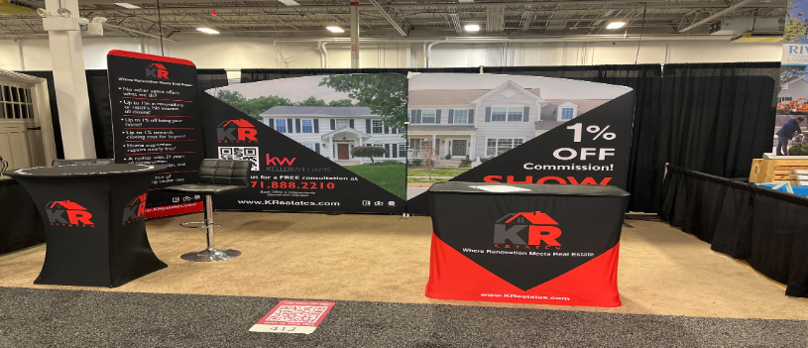

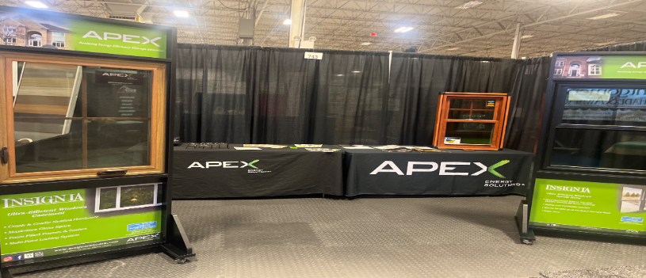

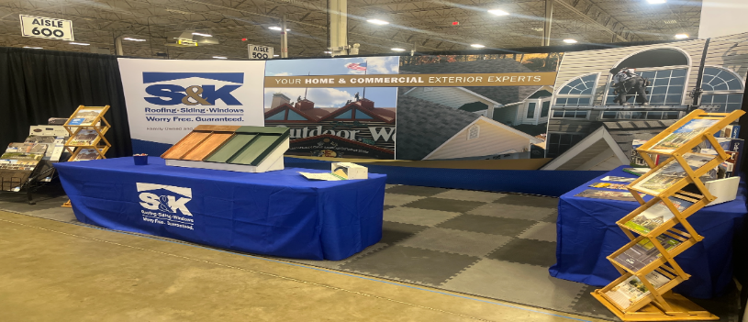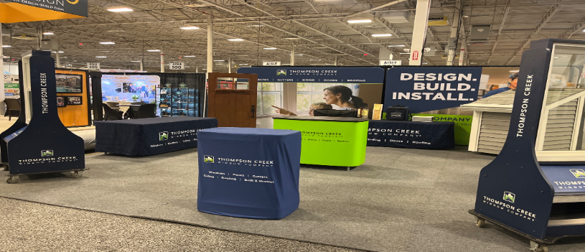

# Where can I purchase ﬂoor covering?

* Any of the box retail stores like Walmart, Target, or Costco have pieces for purchase. (Especially during back to school time, for dorms!)
* Some exhibitors have purchased ﬂooring and shared links to purchase:

**Great Mats** [*https://www.greatmats.com/?ut*](https://www.greatmats.com/?utm_source=google&utm_medium=cpc&utm_campaign=FS-Brand&gad_source=1&gclid=EAIaIQobChMIjPWb5pGwhAMVQBCtBh19AQlKEAAYASAAEgIKRvD_BwE)[*m_source=google&utm_medium*](https://www.greatmats.com/?utm_source=google&utm_medium=cpc&utm_campaign=FS-Brand&gad_source=1&gclid=EAIaIQobChMIjPWb5pGwhAMVQBCtBh19AQlKEAAYASAAEgIKRvD_BwE)

[*=cpc&utm_campaign=FS-*](https://www.greatmats.com/?utm_source=google&utm_medium=cpc&utm_campaign=FS-Brand&gad_source=1&gclid=EAIaIQobChMIjPWb5pGwhAMVQBCtBh19AQlKEAAYASAAEgIKRvD_BwE)[*Brand&gad_source=1&gclid=EAI*](https://www.greatmats.com/?utm_source=google&utm_medium=cpc&utm_campaign=FS-Brand&gad_source=1&gclid=EAIaIQobChMIjPWb5pGwhAMVQBCtBh19AQlKEAAYASAAEgIKRvD_BwE)[*aIQobChMIjPWb5pGwhAMVQB*](https://www.greatmats.com/?utm_source=google&utm_medium=cpc&utm_campaign=FS-Brand&gad_source=1&gclid=EAIaIQobChMIjPWb5pGwhAMVQBCtBh19AQlKEAAYASAAEgIKRvD_BwE)[*CtBh19AQlKEAAYASAAEgIKRvD_*](https://www.greatmats.com/?utm_source=google&utm_medium=cpc&utm_campaign=FS-Brand&gad_source=1&gclid=EAIaIQobChMIjPWb5pGwhAMVQBCtBh19AQlKEAAYASAAEgIKRvD_BwE)

[*BwE*](https://www.greatmats.com/?utm_source=google&utm_medium=cpc&utm_campaign=FS-Brand&gad_source=1&gclid=EAIaIQobChMIjPWb5pGwhAMVQBCtBh19AQlKEAAYASAAEgIKRvD_BwE)

# Amazon

*https://*[*www.amazon.com/Yes4All-Interlocking-*](http://www.amazon.com/Yes4All-Interlocking-) *Exercise-Foam-Mats/dp/B088B93N3Y/ref=sr_1*

*_10?crid=79XIZCCMRQRO&keywords=foam%2 Bﬂooring%2Btiles&qid=1669835758&spreﬁx=fo am%2Bﬂooring%2Caps%2C99&sr=8-10&th=1*